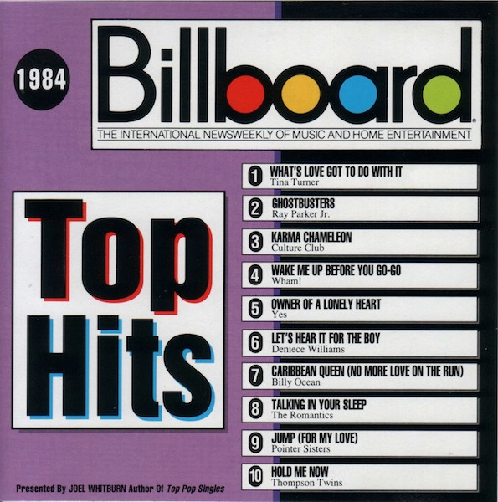
Billboard Top Hits
1984
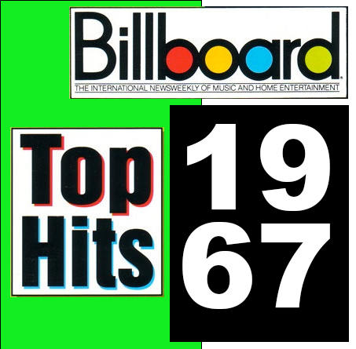
Billboard Top Hits
1967
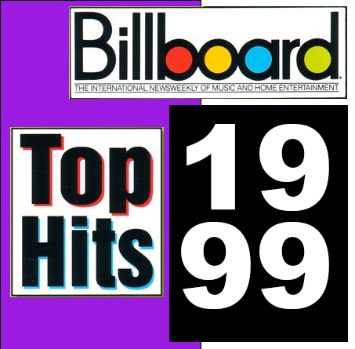
Billboard Top Hits
1999
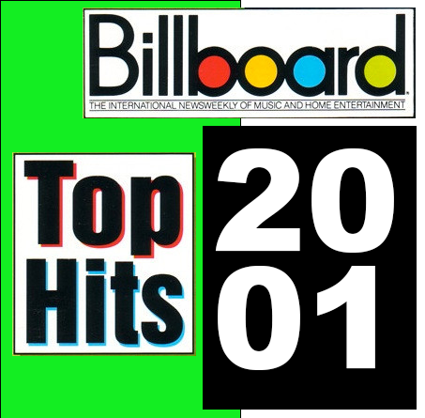
Billboard Top Hits
2001
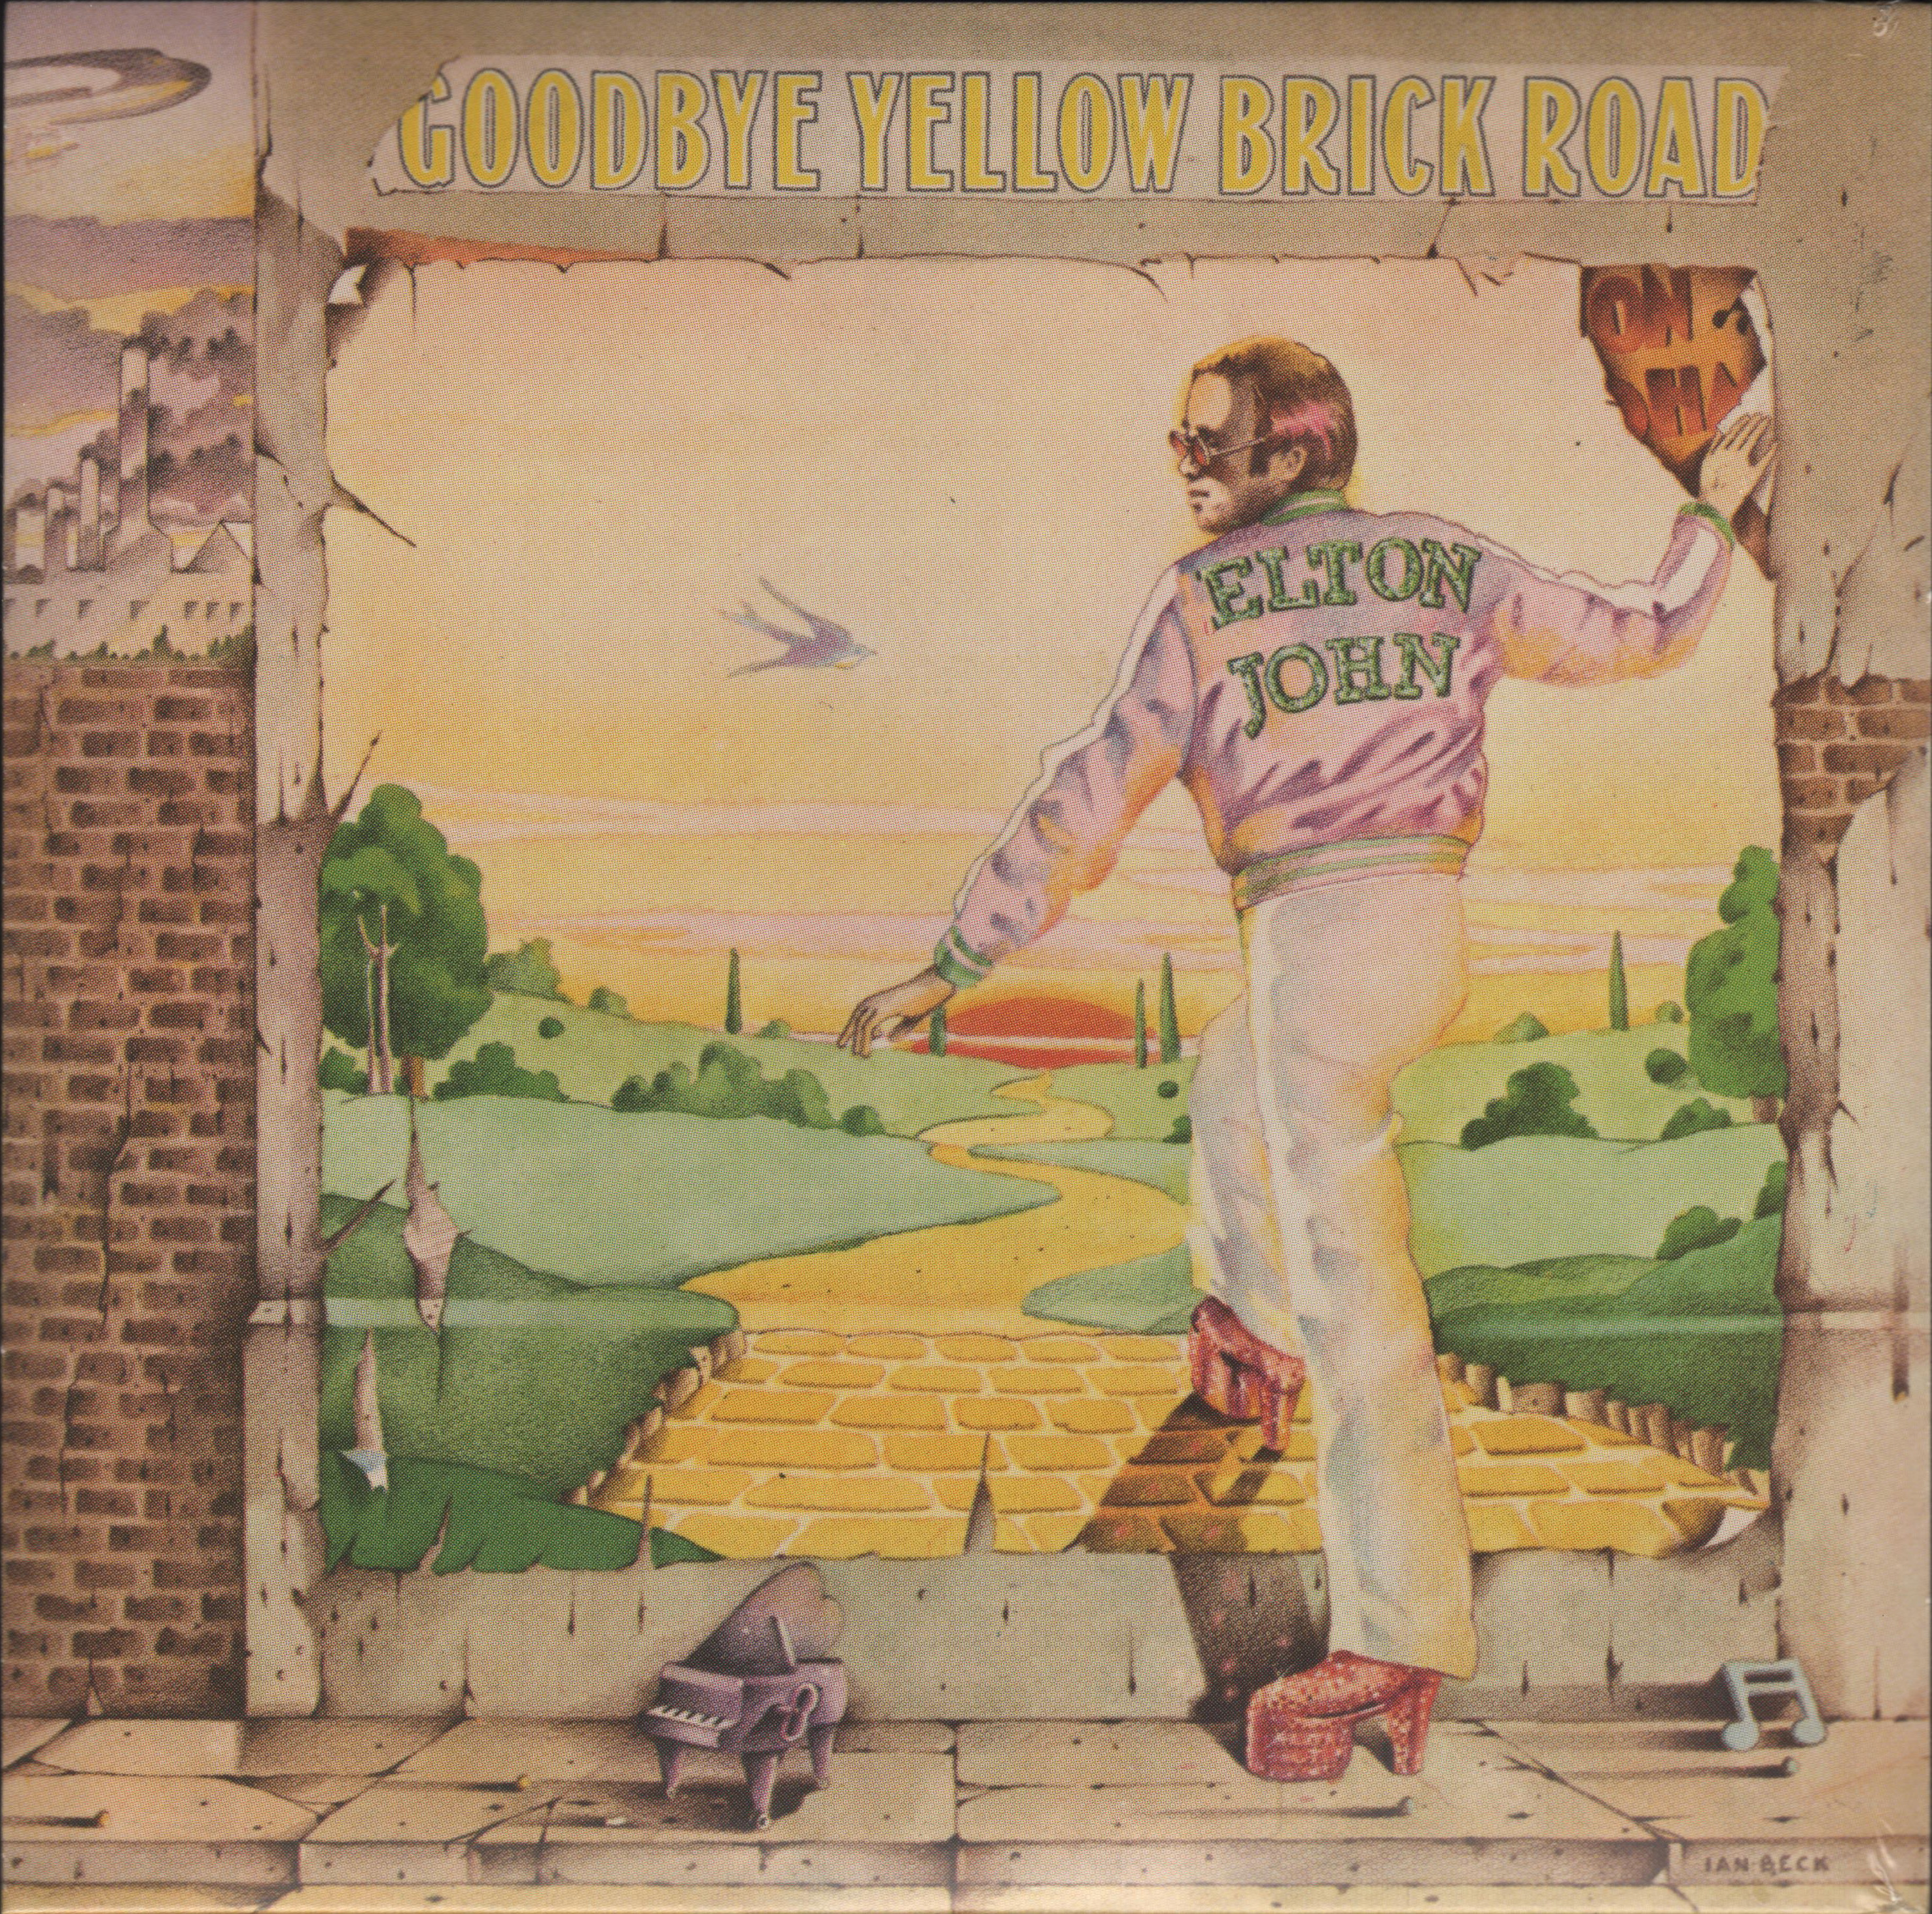
Elton John
Goodbye Yellow
Brick Road
1973
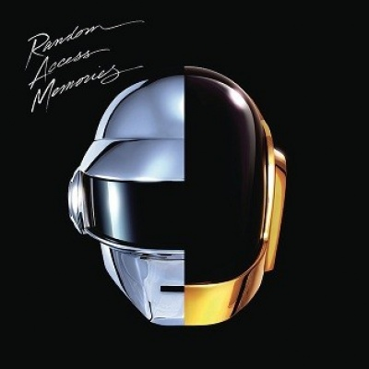
Daft Punk
Random Access Memory
2013
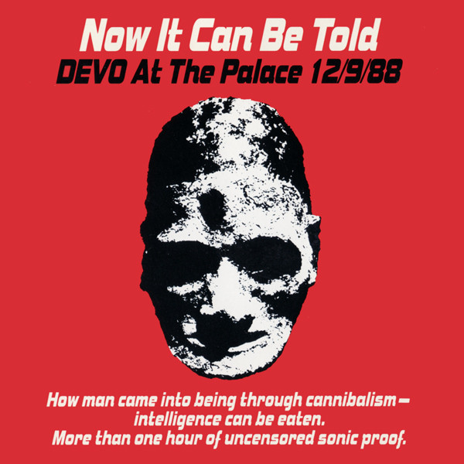
DEVO
Now It Can Be Told
At the Palace 12/9/88
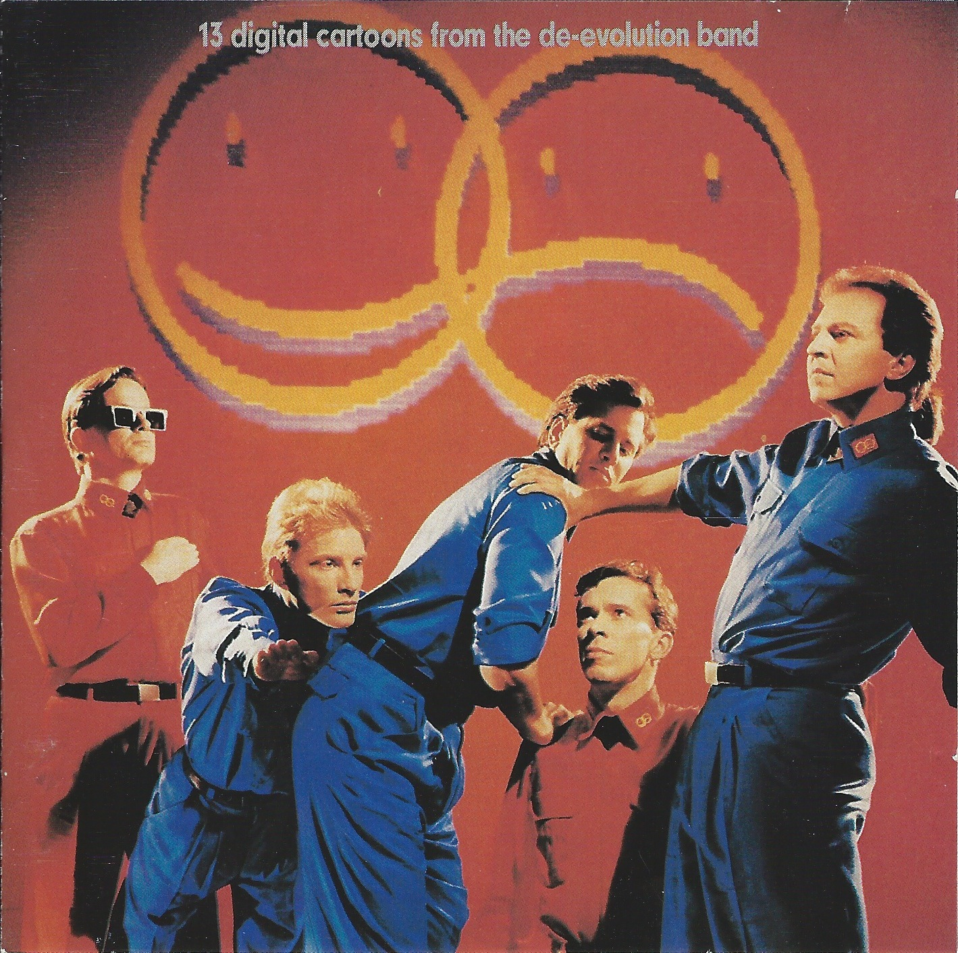
DEVO
Total Devo
1988
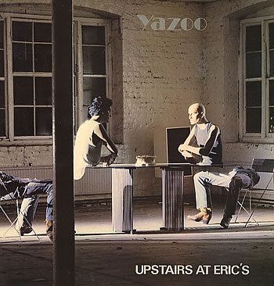
Yaz
Upstairs At Eric’s
1987
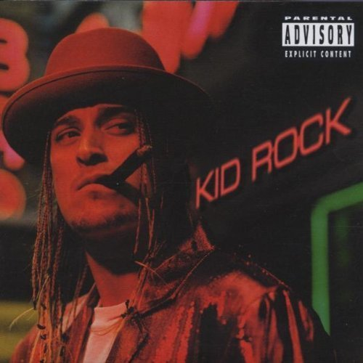
Kid Rock
Devil Without a Cause
1999

Marylin Manson
Mechanical Animals
1998
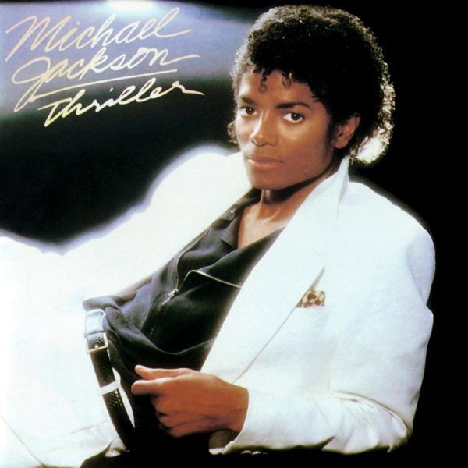
Michael Jackson
Thriller
1982

